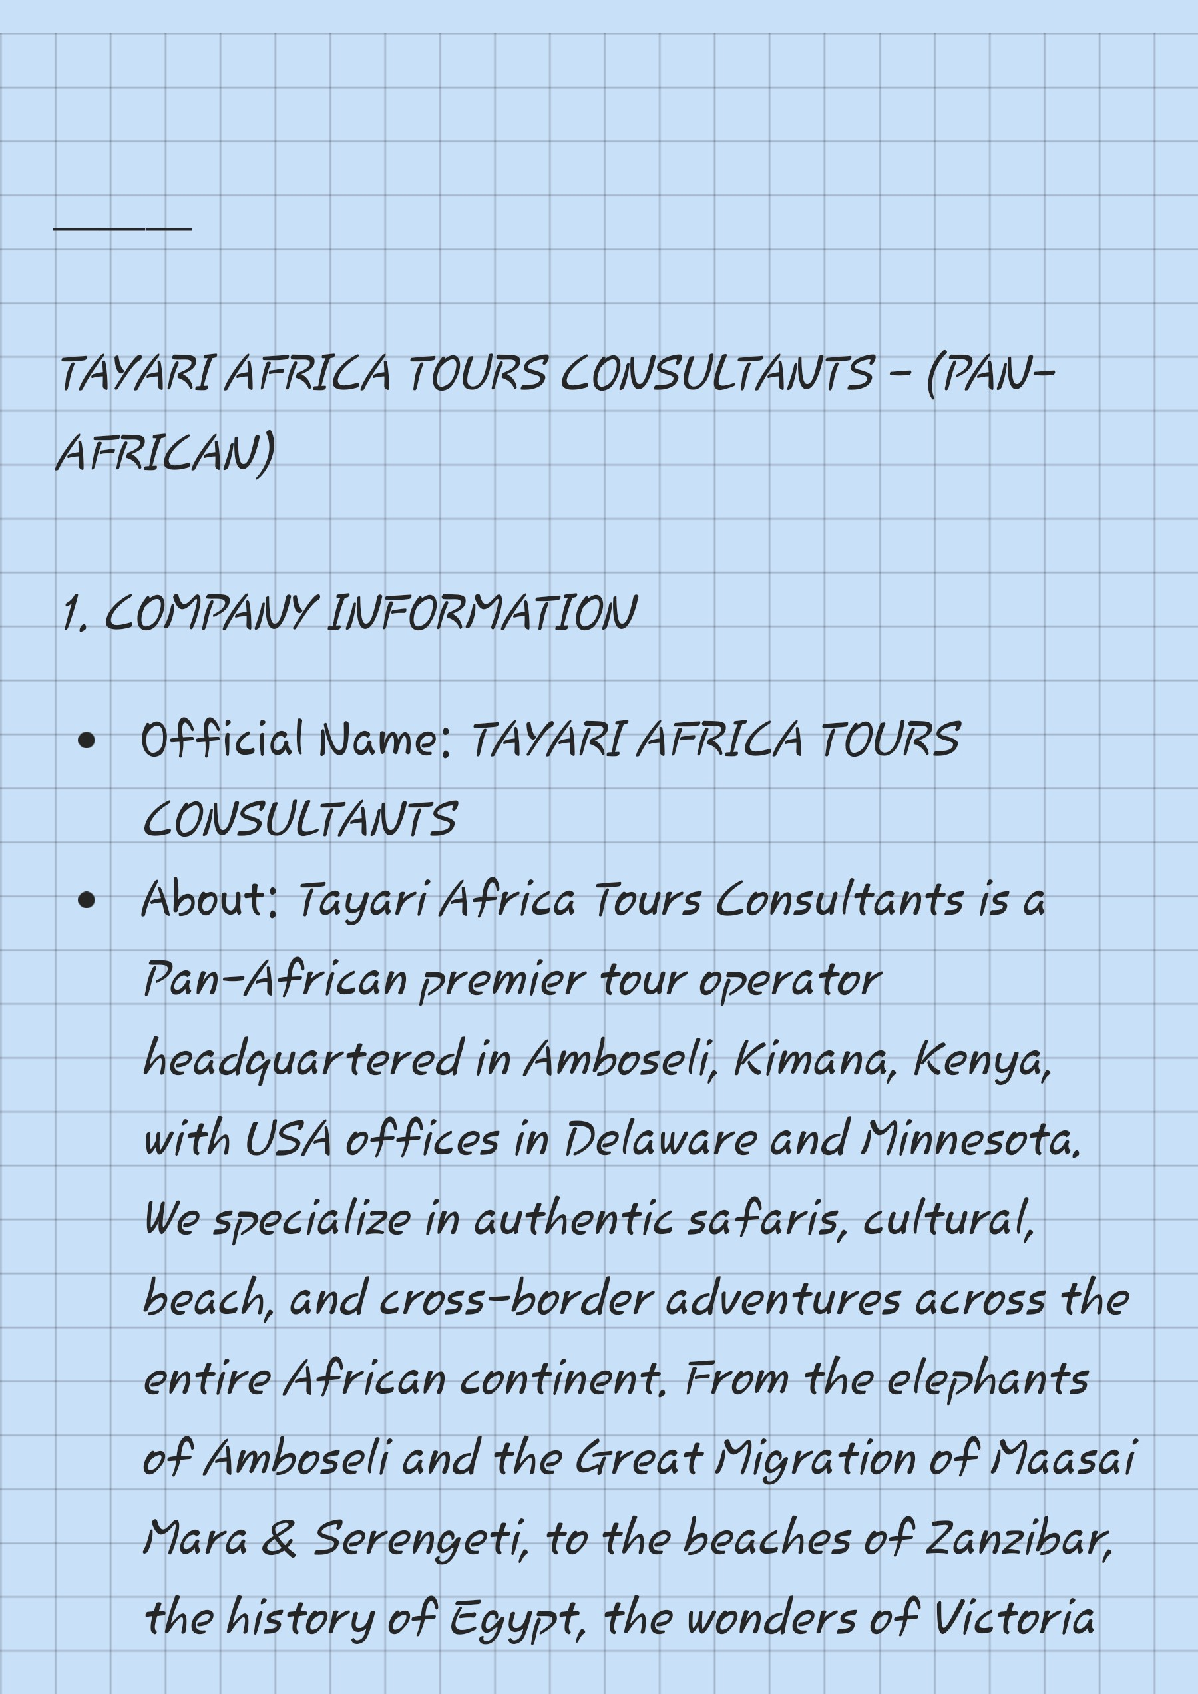

, DRA/VD1/V4
Cog03At ached (Gold #CI A3i) Tayari script +
Acacia Tree + ica Map

Tayarit
A F R I C A T O U RS
Tour 1, Ambose i] Gtional ^{D}ar -Kenya —2D/1/V
' We site Price: From $380 KES 36,500 pp
I dudes: 4x4 ruisere •ark feest
Accommo ationt ea st Gui e
lour , JYGGSGDYGKG - Kenya - D 2M Great Migratio
